JOIN OTHERS YOUR AGE IN EXPLORING HOW TO BREAK NEGATIVE THOUGHT PATTERNS. LEARN LIFETIME SKILLS TO BUILD POSITIVE CHANGE, OVER THE COURSE OF 8 WEEKS. MIDDLE SCHOOLERS OF ANY GENDER AND/OR IDENTITY ARE WELCOME

Building Confidence & Self Esteem

Middle School
(Grades 6-8)

Group Facilitator: Bryenne Alesch M. ED, CCATP, CTMH (she/her)
When? Mondays 3:30-4:30p, beginning February 1, 2021

Where? Elite Cognition LLC Office in the Water Tower Place Building
5900 Monona Drive Suite #200, Monona WI 53714

How do I Join? Email bryenne@elitecognitionllc.com or call 608-286-1132 x10 to complete a quick (one time) registration form, prior to your first session

Cost? $45/session or $320, if paid in full prior to first session. Materials included in fee.
*CCS programing participants should register through your Service Facilitator

Note: This is an In-Person group. The following protocols and precautions will be in place and must be followed by all participants. Should our agency close or change protocols due to Covid-19, participants will be notified immediately.
- Group size is limited to 6 participants
- Be on time to group & Commit to attend all 8 weeks
- Wear a mask in the building & while in group
- Sign Covid-19 Health Check and Exposure Policy Agreement
- Wash hands, (soap & water or sanitizer) as you enter session
- Do not come to group if you are sick or have symptoms
- Strict sanitation protocols of the space will be followed before/after each session
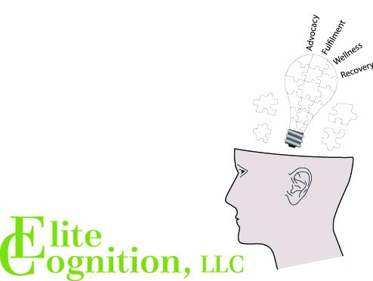
  - ELITE COGNITION, LLC
  - 5900 MONONA DRIVE
  - SUITE #200
  - MONONA WI 53716
  - 608-286-1132
  - www.elitecognitionllc.com

